September 21st
December 2020
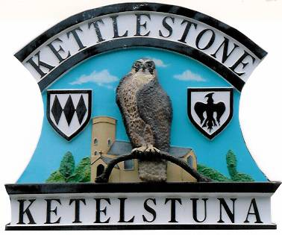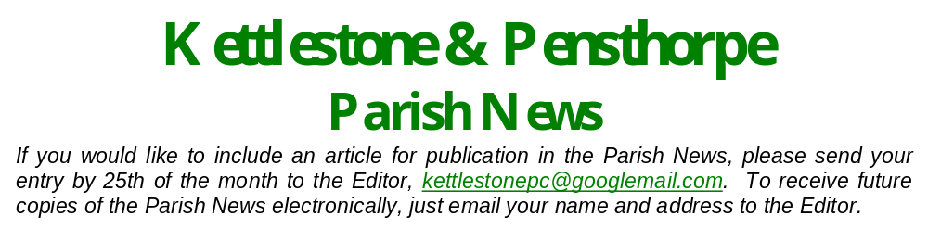
Kettlestone & Pensthorpe Parish News

If you would like to include an article for publication in the Parish News, please send your entry by 25th of the month to the Editor, kettlestonepc@googlemail.com.
To receive future copies of the Parish News electronically,
just email your name and address to the Editor.
Kettlestone Parish website: https://kettlestoneparishcouncil.norfolkparishes.gov.uk/

Kettlestone
Parish Council

Contact details
Clerk
Joanna Otte
Little Manor,
Thursford Rd
Lt Snoring, NR21 0JN 01328 822366

Councillors
Gill Ashby
Chair
878639
David Burgis
878474

Vacancy

Christine Hipkin
878241
Marlene Hoad
822101
Trevor Hoad
822101
Robert Kilbourn
Vice-Chair
851633
Kettlestone Parish Council
The main item to consider at the recent Parish Council meeting was the Budget and Precept for next year. It was agreed to keep the Precept at the same level as the previous year.
The next meeting is on Monday 18 January 202. Meetings, at least for the time being, are held via Zoom which allows for parishioners to ‘attend’ and have oversight if they so wish. The link for a meeting is available on the website at least three workings days prior to the meeting. If you have anything that you would like to bring to the attention of the Parish Council you can do so at the meeting or via email kettlestonepc@googlemail.com or telephone 822366. The website also has links to local information and support groups.
Kettlestone Parish website: https://kettlestoneparishcouncil.norfolkparishes.gov.uk/

Vacancy on the Parish Council
If you wish to be considered for co-option to Kettlestone Parish Council, please write to the Clerk (address above) or email kettlestonepc@googlemail.com , providing a brief description of yourself and what you can bring to the role of Parish Councillor.
We look forward to hearing from you.

 Christmas trail
At Halloween it was lovely to walk through the village and see the various pumpkins on display. To continue with the theme, the various village organisations are promoting a Christmas trail. We hope that this will give people something to look forward to and enjoy, regardless of the lockdown status!
It would be lovely to see Christmas decorations displayed in or outside as many houses as possible, from a single bauble or Christmas drawing to a decorated tree, or maybe a big display of lights!

From the Village Hall Committee
From all on the Village Hall Committee: may we wish everyone a Very Merry and Happy Christmas, and a healthy, prosperous and as near a “normal” New Year as possible. We will be looking forward to re-opening the Hall at some stage, and hope that it’s not too long to wait.


Covid-19 Hardship Grants
Hardship Grants are available if you are experiencing difficulties as a result of the pandemic.
If you are in need or hardship, please do consider applying for a Covid-19 Hardship Grant from the Parish Council. (Your application will be considered by a working group of parish councillors supported by the Clerk and will remain confidential.)
For an application form for a Covid-19 Hardship Grant, please do contact the Parish Clerk on 01328 822366 or email: kettlestonepc@googlemail.com

Message from the Chair of the Parish Council

Hellos and goodbyes

The last year has been one that I’m sure everyone will remember; the worries as we saw the Covid-19 epidemic spread from China, the increasing number of cases in the early part of the year, and then the first lockdown. The overwhelmingly depressing news. Roads quieter than for many years, non-essential shops shut, and for many people the initial concerns about getting food without taking the risk of venturing in to the supermarkets. Then a period of some respite, followed by a second lockdown. Although North Norfolk has been, and continues to be, an area with relatively low prevalence of the virus, we all know that some families have sadly lost loved ones and others have struggled with not being able to socialise and visit their families. Many villagers have helped others out during the pandemic, for which we thank them. Let’s hope that the news of vaccines remains positive and that we can return to some kind of normal in the next few months.

On reflecting on the year in the parish it is evident that this has been a time of high turnover, with several people (including long standing residents) moving (or planning to move) out, and of
course new residents moving in. I would like to take this opportunity to wish all those
who are leaving or who have left the village the very best for the future, and please do
stay in touch. For those who have joined or are joining the village, a very big welcome.
Sadly this has not been a year in which we have been able to socialise much, but I look
forward to meeting up with everyone as soon as it is safe to do so.

I would like to wish everyone a happy Christmas, and hopefully an opportunity to celebrate with family and friends. But perhaps more importantly, I wish everyone good health and a return to a new normality soon.
Gill Ashby

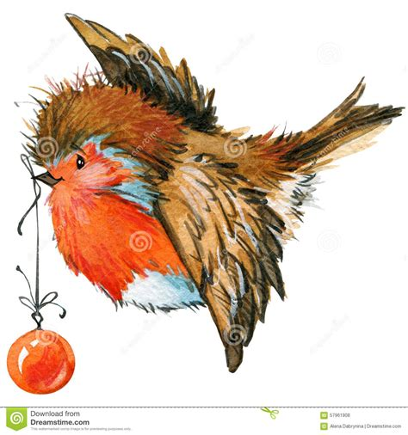

Book swap in the bus shelter

The book swap has been a boon in this difficult year; it has been very well supported and the range of books and magazines has been amazing. A full range of fiction books, and many non-fiction books ranging from painting to pasta and everything between, with regular new additions evident.

Just a few guidelines on the use of the bus shelter though. Use is for books, magazines, CDs and DVDs. Surplus produce is also welcome, but please don’t leave any other items there.

We may use the bus shelter for other initiatives at various times, whether a
sale for a village organisation, or as a collection point for item such as
flower pots. However, these will be limited time events and always
advertised in the newsletter (and generally rely on better weather).

Many thanks to Louise for looking after the book swap.



Happy Christmas from Pat!
Pat Dickson would like to wish all villagers a very merry Christmas and a happy and healthy new year. In lieu of sending Christmas cards this year Pat will be making donations to the church and village hall.




Views expressed in this publication are not necessarily those of the Editor or of Kettlestone Parish Council.
Poppy Appeal
I regret that I was not allowed to make the usual 'house to house' collections for the Poppy Appeal this year. However, during the short service held in the Churchyard and donations put in the bucket at my house I am pleased to say that a cheque for £360 has been sent direct to the Royal British Legion. Please accept my sincere thanks to all who contributed so generously to such a worthy cause. Alec Peck

Andrew and Julia Murray wish everyone the best Christmas possible and a better 2021. As usual we will make donations to the Church and the village hall in lieu of sending cards

