KETTLESTONE VILLAGE HALL EVENTS

Friday 17 August:
BBQ and Games Evening
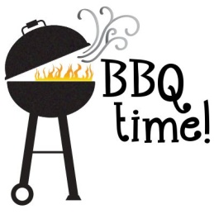

Sunday 9 September:
Village Boules Competition

Thursday 26 Sept:
MacMillan Coffee Morning
For your diaries:
Harvest supper: 29th September
Quiz and chips: 20th October
Remembrance weekend: 10th – 11th November
Christmas dinner: 8th December

