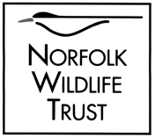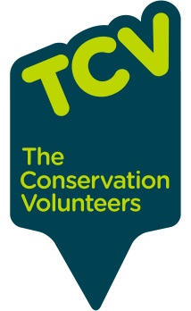
Kettlestone Surveyor’s Allotment
Initial recommendations based on site visit 09/05/16
EXPRESSION OF INTEREST. I, Mark Webster, am employed part-time by both NWT and TCV. This report contains contributions from both organisations, but as they are compatible with each other I have not separated them. Nevertheless, please note that as an NWT employee I am currently able to free advice to landowners in or adjacent to the North Norfolk Woods Living Landscape, especially close to Bretts Wood. As a TCV employee I can offer services including volunteer practical tasks, these services tend to be chargeable but TCV can also seek to raise external funding for such works. A second opinion on whether to involve TCV could be sought from my colleague at NWT Gemma Walker who can be reached via GemmaW@norfolkwildlifetrust.org.uk 01603 625540. Other contractors are available – whilst as an NWT employer I cannot recommend any particular company or person, I can provide details of people who we have used before for similar jobs.
Main site features (see also sketch map)
A path runs across the site from a gate at the NW corner to an entrance at the S corner. This remains mostly passable with care. A few knapweed plants were present where the ground was trodden down along the path.
The site appears to have quite a limited flora generally, dominated by rank grasses, bramble, bracken and stinging nettle, all suggesting a high level of nutrients which is not good for wildflowers or biodiversity in general. A full survey was not carried out but other plants seen in the middle of the site include dog rose, hogweed, common sorrel, thistles, rushes and dock.
A very small patch of wildflowers including campion, ground ivy and hedge woundwort is hanging on under the trees at the S entrance to the site.
The site has a line of hawthorn trees along its SW boundary (presumably a grown-out hedge) and a fringe of trees – mainly willow with elder – creeping in from the NE edge. Aerial photography and local knowledge has the site much more open in recent years. A few small oaks are present in the middle of the site. Blackthorn is present, especially as a patch near the NW entrance.
As well as the willow, there is a patch of sedges and another of especially lush tall grass indicating wetland habitat areas in the NE half of the site, this is to be expected as the site slopes down from the SW to a flatter area along its NE half as part of an overall downward slope towards a small stream - 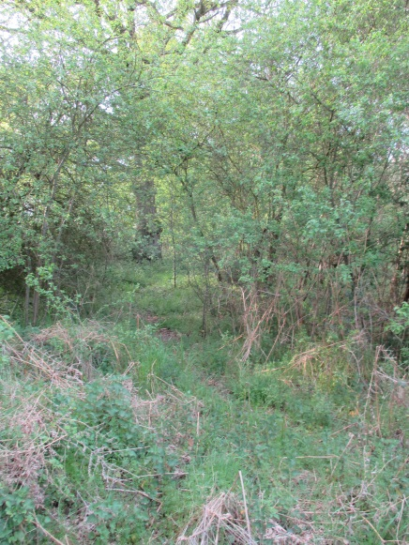which in turn eventually feeds into the River Wensum.
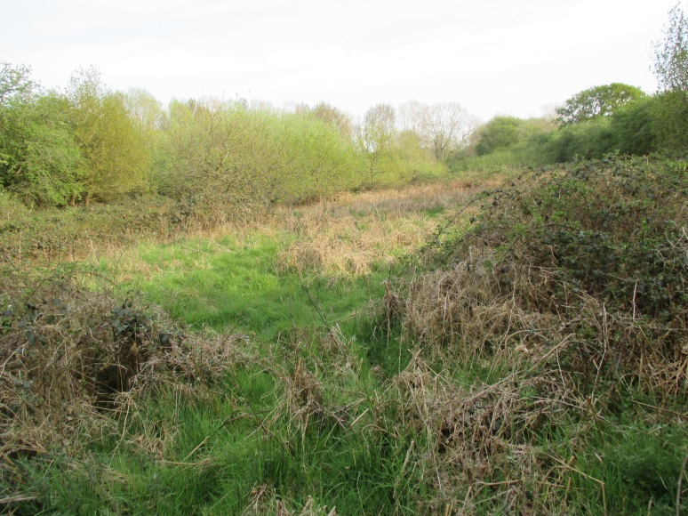
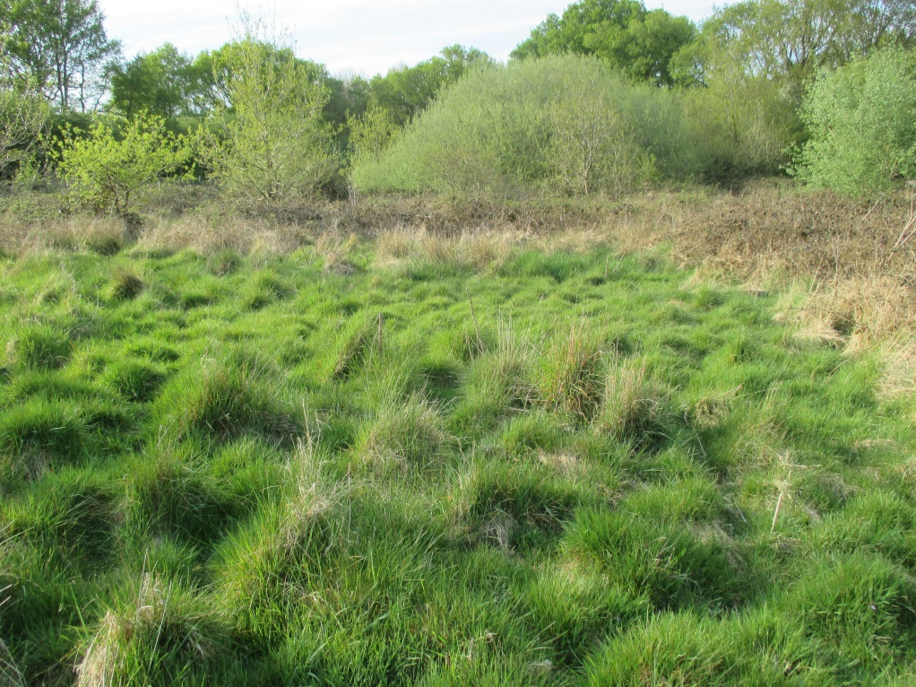
Opportunities and Challenges
The site is approximately 1 mile from Kettlestone’s houses, approx. ½ km from the road. Trackway access to the site is largely in good condition. There does not seem to be an obvious circular route going past the site though, so people will need to have a reason to go there, which at present is lacking.
Recommendations
- Re-establish the main path, by cutting back encroaching trailing stems of brambles etc once a year, or asking if the owner of the neighbouring woodland will cut a path through your site when they are doing theirs. Install signs at either end of the site letting people know it is there and public access is allowed. Consider leaving the gate open as it currently seems to serve no obvious purpose.
- Consider removing topsoil from an area on the slope to see if wildflowers which have been lost from the site will re-establish themselves from a seed bank in the soil. Disposal of topsoil elsewhere on site (e.g under blackthorn or bramble).
- Plant up grassy areas with a mixture of native flowering shrubs (as ‘whips’ i.e. 1-3 year old seedling trees) and fruit trees (as 5-6 ft tall young trees) – perhaps Norfolk heritage varieties and/or good croppers. Tree planting is a great way to encourage the community to come to the site and feel a sense of ownership “that’s my tree”. People will then have a reason to come back to the site, to check on and look after their trees, and to eat the apples, pears, plums etc. Planting to be relatively low density, to maintain an open feel to the main part of the site.
- Clear some areas of the bramble for small plots – mini-allotments available to anyone who wants to cultivate them for vegetables, cut flowers, etc.
- Dig a small wildlife pond amongst the wetland area.
Estimated Costs
Item | Purpose | Cost (£) | Time of year
1 day’s mini-digger hire | Pond, wildflower scrape and cultivation plots | 250 | Any except Spring
Liner, plants etc | Creating Pond | 300 | Any except Spring
200 ‘whips’ with spiral guards and canes, and 25 fruit trees with stakes and solid tube guards | Planting up 200 mixed native trees and 25 fruit trees | 900 | Autumn-Winter
3 days labour by volunteer group | Brushcutting path, clearing bramble/bracken, pond work, tree planting (including supervision of local volunteers, use of tools, insurance, transport to site). | 750 | Summer (paths); Autumn- Winter (trees).
2 signs | Welcoming people to the site | 50-500 | Any

Prepared by Mark Webster MarkW@norfolkwildlifetrust.org.uk 07843 069 567

